The Lord’s Prayer
Our Father who art in heaven, hallowed be your Name, GOD
Your Kingdom come; your will be done
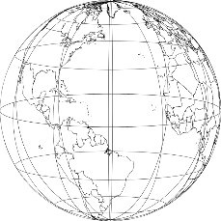
On earth as it is in heaven.
Give us today our daily bread;
and forgive us our sins, as we forgive those who sin against us; XBadX
and lead us not into temptation, but deliver us from evil.
For yours is the kingdom for ever and ever.
Amen.

