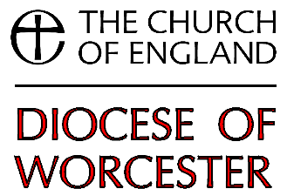
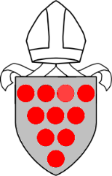

Bishop’s Certificate Course Tutor’s Evaluation

Thank you for tutoring a Bishop’s Certificate group. Please take a few moments to fill in this form as it will help us go forward for future groups.
The completed form should be returned to training@cofe-worcester.org.uk or post to: Department of Ministry & Discipleship, The Old Palace, Deansway, Worcester WR1 2JE

- What brought you to become a tutor?
2. What did you enjoy most about running the course?
3. Which parts of the course worked best?
4. What didn’t work so well?
5. Did you add any extra elements to the course (eg trips or visits, quiet days, individual meetings with group members)?
Would you recommend these for future groups to consider?

6. Do you have any suggestions on how we can improve the course?

7. Is there anything you would like to discuss about your experience
8. Would you consider running another course in the future? If yes, in which area(s) of the diocese would you be willing to do this?
9. Would it be helpful for tutors to attend any training or review sessions before/during/after the course, if yes, please say what you would find most useful
10. Are there any comments you would like to feed back?
Thank you.

